Please find below the Lab for Real Time Data Analytics course. Kindly make your submission before the deadline.

**Question:** you are receiving a stream of 2D points and you need to keep a count of how many points fall in each quadrant.

* 2D Points : (x,y)
* 4 quadrants

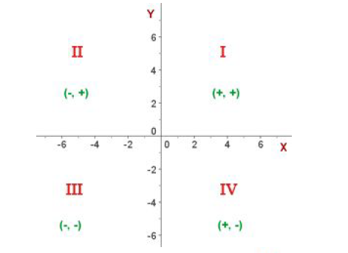

* Example :
* (1,5) = quadrant 1
* (-7,4) = quadrant 2
* (-5,-9) = quadrant 3
* (2,-6) = quadrant 4